COLORADO AMERICAN BAPTIST
WOMEN’S MINISTRIES CONFERENCE

June 10-11, 2022
Embassy Suites by Hilton, Denver Tech Center North
SAVE THE DATE!
7525 East Hampden Avenue, Denver, CO 80231

Theme: Let the Walls Fall Down

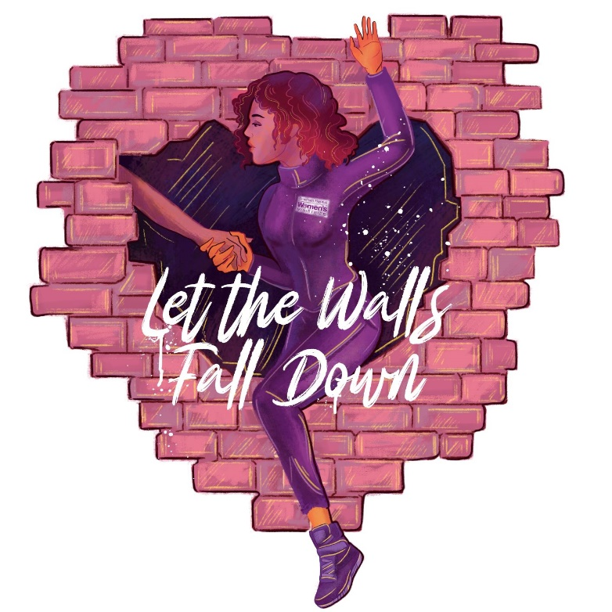
Ladies come and get refreshed and rejuvenated.

If you have questions about the conference or want further information, call:

Rev. Dr. Kay Farley, 303-909-8637 or Dr. Jamie D. Johnson, 720-879-2700

